Create a React App named “bloggerapp” in with 3 components.

1. Book Details
2. Blog Details
3. Course Details

Implement this with as many ways possible of Conditional Rendering.

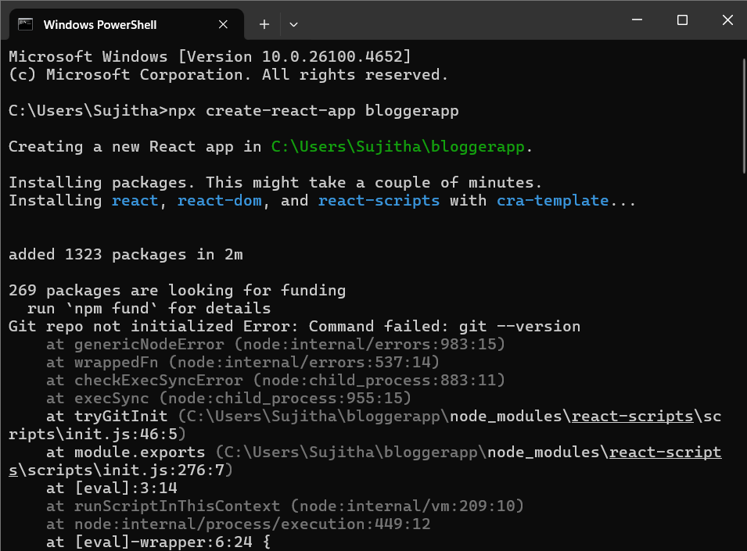

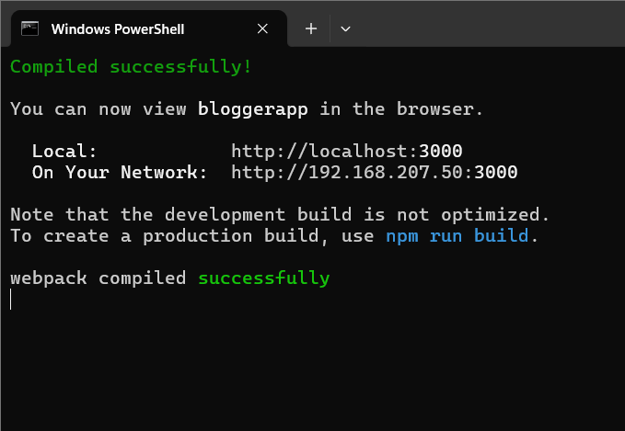

**App.js**

import React from 'react';

import CourseDetails from './components/CourseDetails';

import BookDetails from './components/BookDetails';

import BlogDetails from './components/BlogDetails';

import './App.css';

function App() {

  return (

    <div className="container">

      <CourseDetails />

      <BookDetails />

      <BlogDetails />

    </div>

  );

}

export default App;

**App.css**

.container {

  display: flex;

  justify-content: space-around;

  margin-top: 40px;

}

.container > div {

  border-right: 4px solid green;

  padding: 0 20px;

  flex: 1;

}

.container > div:last-child {

  border-right: none;

}

**CourseDetails.js**

import React from 'react';

function CourseDetails() {

  return (

    <div>

      <h2>Course Details</h2>

      <h3>Angular</h3>

      <p>4/5/2021</p>

      <h3>React</h3>

      <p>6/3/20201</p>

    </div>

  );

}

export default CourseDetails;

**BookDetails.js**

import React from 'react';

function BookDetails() {

  return (

    <div>

      <h2>Book Details</h2>

      <h3>Master React</h3>

      <p>670</p>

      <h3>Deep Dive into Angular 11</h3>

      <p>800</p>

      <h3>Mongo Essentials</h3>

      <p>450</p>

    </div>

  );

}

export default BookDetails;

**BlogDetails.js**

import React from 'react';

function BlogDetails() {

  return (

    <div>

      <h2>Blog Details</h2>

      <h3>React Learning</h3>

      <strong>Stephen Biz</strong>

      <p>Welcome to learning React!</p>

      <h3>Installation</h3>

      <strong>Schwezdenier</strong>

      <p>You can install React from npm.</p>

    </div>

  );

}

export default BlogDetails;

**Output**

